ATTACHMENT 9

CONSIDERATION OF

COVERAGE FOR APPURTENANCES
Proposed Expansion of MSI Coverage

Background:

For many years, the MSI Board has considered lowering premium rates or expanding coverage. Considering the feedback that we have received from policyholders, the public, and insurance producers regarding how affordable MSI coverage is, the MSI Program Managers now believe an expansion of coverage to be prudent. This expansion of coverage can also be used as a selling point when marketing the program.

Two stipulations will be placed on the expansion of coverage to limit the number of frivolous claims so they do not negatively impact the cost of coverage.

The Insuring Agreement will need to be revised to define what specific appurtenant structures are covered as well as to stipulate the following:

- 1. The insured structure must be damaged before damages to the appurtenant structures can be considered and;
- 2. The amount of the paid loss attributable to covered losses to permanently affixed appurtenances shall not exceed 10% of the amount of insurance shown on the certificate.

Under these procedures, a separate rider would not be needed and a single policy would cover the main structure and other appurtenances up to 10% of the policy limit or maximum amount of coverage. Any building that meets the MSI definition of an “insured structure” can only be covered under a separate policy.

Proposed Revisions to the Insuring Agreement:

The proposed expansion of coverage would be implemented through revisions to the Insuring Agreement that are indicated in the proposed revisions that are a part of this attachment.

Supporting Data:

Data was collected and analyzed regarding appurtenant structures for a set of fifty (50) valid MSI claims dating back to September 2001. Of these 50 supported claims, 46 have been settled, and therefore have complete data regarding claim payments. As of June 2, 2006, the remaining 4 claims are still being processed and therefore not included in the analysis.

The data supporting the proposed expansion of MSI coverage can be found in the following attached documents.
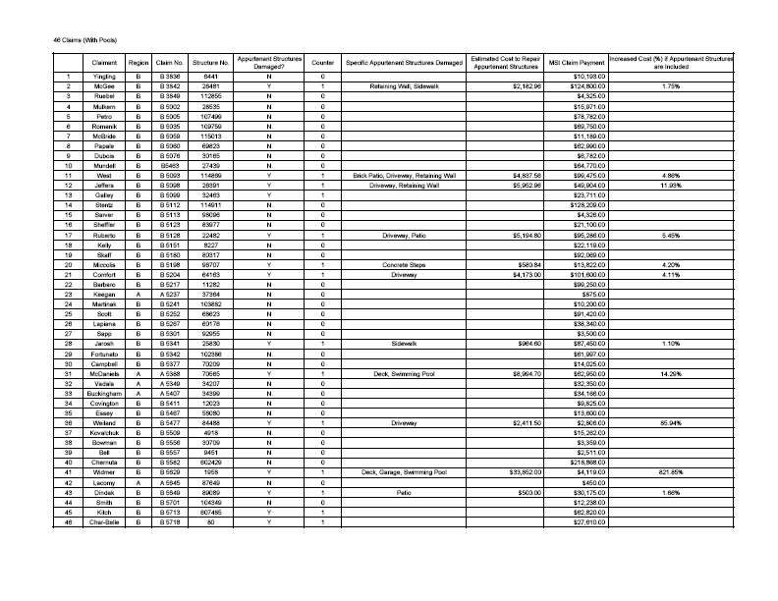
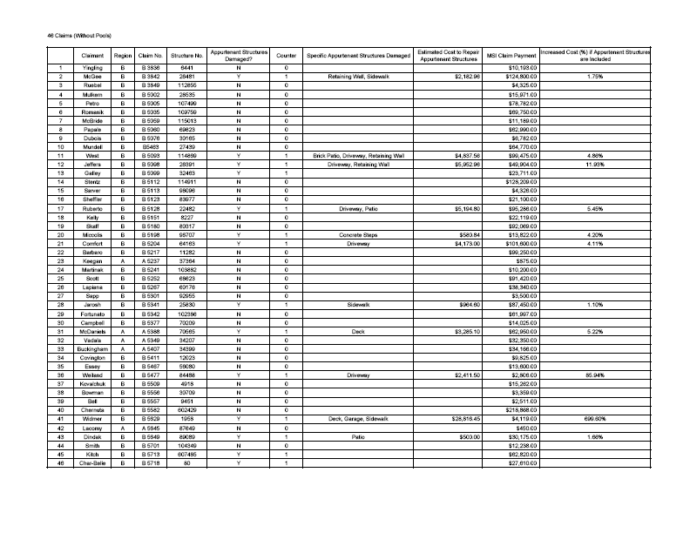

Summary Data -- Sample of 46 Claims
Swimming Pools Included

Number of Reviewed Claims Paid as of June 2006: 46
Total Paid to Settle these Claims: $2,041,339.00
Average Paid per Claim: $44,376.93
Number with Damaged Appurtenant Structures: 14
Percent with Damaged Appurtenant Structures: 30.4%
Estimated Amount to Repair Appurtenant Structures: $69,644.92
Percent of Claim Cost Increase to Repair Appurtenant Structures
(Compared with Total Paid): 3.41%
Increase Cost per Claim (Compared with Total Number Paid): $1,514.02

Summary Data -- Sample of 46 Claims
Swimming Pools Not Included

Number of Reviewed Claims Paid as of June 2006: 46
Total Paid to Settle these Claims: $2,041,339.00
Average Paid per Claim: $44,376.93
Number with Damaged Appurtenant Structures: 14
Percent with Damaged Appurtenant Structures: 30.4%
Estimated Amount to Repair Appurtenant Structures: $58,899.77
Percent of Claim Cost Increase to Repair Appurtenant Structures
(Compared with Total Paid): 2.89%
Increase Cost per Claim (Compared with Total Number Paid): $1,280.43

7C-K-110
5600-FM-MR0062 Rev. xx/xxxx

COMMONWEALTH OF PENNSYLVANIA
DEPARTMENT OF ENVIRONMENTAL PROTECTION
BUREAU OF MINING AND RECLAMATION
MINE SUBSIDENCE INSURANCE FUND
INSURING AGREEMENT
1. DEFINITIONS. Throughout this policy, “you” and “your” refer to the Policyholder(s) named on the Certificate of Mine Subsidence Insurance, and the “Fund” refers to the Coal and Clay Mine Subsidence Insurance Fund and its designated representatives. In addition, certain words and phrases are defined as follows:
A. CERTIFICATE refers to the Certificate of Mine Subsidence Insurance;
B. COST OF REPAIR refers to the cost of repairing or replacing the LOSS to the INSURED STRUCTURE with material of like kind and quality, within a reasonable time after the LOSS;
C. DAMAGE CLAIM NOTICE refers to the form supplied by the Fund and used by the claimant to list all damages being claimed;
D. INSURED STRUCTURE refers to a complete building and its appurtenances, or a building under construction and its appurtenances, that is described in the CERTIFICATE and in the Mine Subsidence Insurance Application, and to which you can establish legal title; it does not include grounds surrounding the described building;
E. LOSS refers only to physical damage to the INSURED STRUCTURE and to any permanent improvements within the structure; it does not include damage to contents, personal property of any nature, or loss of use of the INSURED STRUCTURE;
F. appurtenances refer to fences, retaining walls, paved or improved patios, walks, driveways, and in ground swimming pools. All appurtenances must be permanently affixed and securely attached to the land surface and adjacent to and used in conjunction with the part of the structure that is the building.
[F]G. POLICY refers to the CERTIFICATE, this INSURING AGREEMENT and the Application for Mine Subsidence Insurance;
[G]H. MINE SUBSIDENCE refers to the movement of the ground surface as a result of the collapse of underground coal or clay MINE WORKINGS;
[H]I. MINE WORKINGS refers to the roof, floor, or pillars within an underground coal or clay mine;
[I]J. POLICY PERIOD refers to the time beginning when the POLICY is issued through all subsequent and continuous renewals of the POLICY.
2. COVERAGE.

A. Except as provided for in paragraph B of this section [T]this policy covers only LOSS to the INSURED STRUCTURE which occurs during the POLICY PERIOD and which is caused by MINE SUBSIDENCE or which is caused by movement of the ground surface resulting from a surface discharge due to a sudden and unexpected breakout of water directly emanating from underground coal or clay mine workings. This policy does not cover losses due to discharges from a man-made system designed to collect or convey mine water, or damages that are related in any way to surface mining activities.

B. LOSS to APPURTENANCES are covered only if it is first determined that the same event is responsible for a covered LOSS to that part of the INSURED STRUCTURE that is the building.
3. COVERAGE UNDER THIS POLICY SHALL BE VOID where:
A. the LOSS is due to mining operations under the insured’s control;
B. you fail to comply with any of your obligations under this agreement unless noncompliance is consented to by the Fund; and
C. you have waived, bargained away or forfeited whatever right you have to recover a loss from a third party.
4. AMOUNT OF LOSS PAID. [Each LOSS covered by the POLICY shall be adjusted separately, but all covered damage occurring within a six (6) month period shall be adjusted as a single LOSS.] All LOSS covered by the POLICY that results from a single covered event shall be adjusted under the same claim provided that the amount of the paid LOSS attributable to the covered LOSS to the APPURTENANCES shall not exceed 10% of the amount of the insurance shown on the CERTIFICATE. For a LOSS covered by this POLICY, the Fund will pay the smaller of the following amounts:
A. the amount of insurance shown on the CERTIFICATE; or
B. the COST OF REPAIR, less the deductible shown on the CERTIFICATE.
5. POLICY DURATION. The duration of this POLICY will be[:
A. for a complete structure,] limited to one year[; or
B. for a building under construction, limited to 18-months or when the structure is 80% complete, whichever occurs first].
6. POLICY RENEWAL. Except as set forth in Section 10, a POLICY [for a completed structure] is renewable without a new inspection. [A POLICY for a structure under construction is not renewable.]
7. YOUR DUTIES WHEN LOSS OCCURS. In case of a LOSS covered by this POLICY, you shall see that the following duties are performed:
A. notify the Fund immediately of a LOSS believed to be covered by this POLICY ;
B. within sixty (60) days of receiving the [FUND’S] Fund’s DAMAGE CLAIM NOTICE , return the completed document to the Fund;
C. fully cooperate with the Fund’s agents in carrying out the investigation of the claim. At a minimum you shall:
i. allow the Fund to inspect the INSURED STRUCTURE and the surrounding grounds as often as may be necessary;
ii. allow the Fund to conduct any tests designed to determine the validity of the claim;
iii. be present at least for the initial investigation by representatives of the Fund and respond to all requests for information concerning the INSURED STRUCTURE and the history of the claim; and
iv. refrain from undertaking any activities which could hinder representatives of the Fund from conducting their investigation;
D. take only those emergency preventive measures as authorized in writing by the Fund, in order to protect the INSURED STRUCTURE from further damage and provide the Fund with copies of all receipts of expenditures for the emergency measures;
E. within sixty (60) days of the receipt of the Fund’s list of Authorized Damages, submit to the Fund two (2) itemized [estimates] bids from reputable experts for the cost of repairing the damages as authorized by the Fund. No [estimates] bids are required if the Fund estimate[d]s that the cost of repair is less than six thousand dollars ($6,000). The Fund may waive the number of [estimates] bids required where you demonstrate an unsuccessful good faith effort to obtain the required [estimates] bids.
8. OPTION TO REPAIR. The Fund will have the option to repair or replace the covered LOSS, instead of making a payment for the LOSS under Paragraph 4. To exercise this option the Fund will notify you within thirty (30) days of receiving the itemized estimates referred to in Subparagraph 7E.
9. SUIT. If your claim is denied by the Fund, in whole or in part, you may appeal the denial pursuant to Section 4 of the Environmental Hearing Board Act, 35 P.S. Section 7514, and the Administrative Agency Law, 2 Pa. C.S. Chapter 5A, to the Environmental Hearing Board (EHB), P.O. Box 8457, Harrisburg, PA 17105- 8457, (717) 787-3483. TDD users may contact the EHB through the Pennsylvania Relay Service, (800) 654-5984. Appeals must be filed with the EHB within 30 days of receipt of written notice of the Fund’s denial unless the appropriate statute provides a different time period. Copies of the appeal form and the EHB‘s rules and practice and procedure may be obtained from the EHB. The appeal form and the EHB's rules of practice and procedure are also available in Braille or on audiotape from the Secretary to the EHB at (717) 787-3483. This paragraph does not, in and of itself, create any right of appeal beyond that permitted by applicable statutes and decisional law.
10. REPAIR OF DAMAGE. The Insured shall provide the Fund with opportunities to inspect the repair work to the INSURED STRUCTURE as the work is being completed. Within one year of the settlement of a claim, the insured shall notify the Fund that the repairs authorized by the Fund have been completed and shall provide the Fund an opportunity to reinspect the INSURED STRUCTURE. If the insured fails to give the Fund this notice and opportunities to reinspect or if the Fund cannot verify that the repairs to the INSURED STRUCTURE were made in accordance with the settled claim, the Fund may refuse to issue or renew a Mine Subsidence Insurance [Policy] POLICY for this INSURED STRUCTURE.
11. SUBROGATION. This POLICY does not release any person, partnership, or corporation, from liability for any LOSS which the POLICY covers. If the Fund makes repairs or makes a payment for a LOSS, you agree that you assign whatever right you may have to recover that LOSS from another party, but only to the extent of the payment or repairs made by the Fund.
12. OTHER INSURANCE OR SOURCES OF REMUNERATION. If you have or secure OTHER INSURANCE OR SOURCES OF REMUNERATION for a LOSS covered by this POLICY, the Fund will be liable for only the portion of the LOSS which the OTHER INSURANCE OR SOURCES OF REMUNERATION will not cover.
13. CONCEALMENT OR FRAUD. The Fund does not provide coverage for any Policyholder who has intentionally concealed or misrepresented any material fact or circumstance relating to this insurance.
14. CANCELLATION OF INSURANCE.
A. The Fund will cancel this insurance:

i. if there has been a misrepresentation of fact which, if known to the Fund, would have prevented it from issuing this POLICY ;
ii. if you fail to pay the premium; or
iii. if you sell or transfer your interest in the INSURED STRUCTURE. Upon cancellation of the POLICY, due to sale or transfer, the Fund will return to you a pro rata portion of your premium for the balance of the POLICY PERIOD, providing you notify the Fund in writing within thirty (30) days from the closing date of the transfer or sale. If notification is not received by the Fund within thirty (30) days, your refund will be pro rated from the date you notify the Fund of such sale or transfer.
B. Policyholders may cancel this insurance at their discretion. When the policyholder directs the Fund to cancel a policy, the Fund will prorate the amount of the refund from the date it receives your written notice or the date for which you are requesting a cancellation, whichever is later.
C. Any policy cancelled within the first ninety (90) days of effectiveness [may] will be charged a processing fee of $10.
15. DEATH OF POLICYHOLDER. If you die during the POLICY PERIOD, your interest in this insurance will automatically pass to the recipient(s) of your interest in the INSURED STRUCTURE.
16. WAIVER. Waiver of any provisions of this agreement by the Fund does not constitute a precedent for other actions under the same provisions, nor does it constitute a waiver of any other provisions of this agreement by the Fund.
17. DISABILITY ANNOUNCEMENT. If you are a person with a disability and you require auxiliary aid, service or other accommodation to read this INSURING AGREEMENT, please contact the Chief of the Mine Subsidence Insurance Section directly at 717-783-9586 or through the Pennsylvania AT&T Relay Service at 1-800-654-5984 (TDD) to discuss how the Fund may accommodate your needs.

