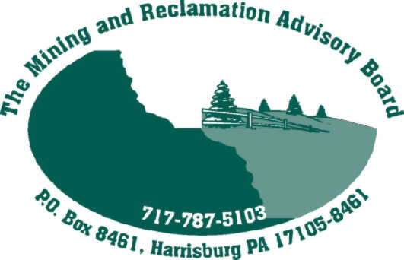 September 18, 2006

Members and Alternates of the Mining and Reclamation Advisory Board (MRAB)

A meeting of the MRAB’s Reclamation Committee is scheduled for October 26, beginning at 9:00 am. This meeting will be held at the DEP, Rachel Carson State Office Building, Delaware Room, 400 Market Street, Harrisburg, PA.

The purpose of the meeting is to review and discuss the issues of concern Dave Strong mentioned at the July MRAB Meeting

Please review my document you recently received via e-mail from Patty Davenport and come to the meeting prepared to discuss these topics.

If you have any questions, need a copy of the items to be discussed, or are a member of the MRAB’s Reclamation Committee and are unable to attend the meeting, please contact Patty Davenport at 717-787-5015 or e-mail her at padavenpor@state.pa.us.

Patricia Davenport (for)
David Strong
Reclamation Committee Chairman

