The Cambria DMO is located at 286 Industrial Park Road in Ebensburg, Cambria County, PA. Phone # 814-472-1900
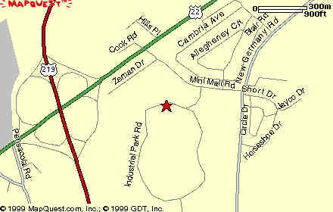
From Pittsburgh and Points West
Follow Route 22 East to Ebensburg. Turn right at the first traffic light on Route 22 (McDonalds on the left). Go approximately ¼ mile, Cambria County Industrial Park sign is on the right, turn right at sign. Continue on roadway less than ½ mile. DEP Cambria Office is on the left, signs says DEP Cambria Office, 286 Industrial Park Road.
From Bedford (Exit 146 - Turnpike Westbound)
Once you exit the toll booth, you will make a left at the stop sign. You will go a short distance and make a left onto Route 220/I-99 North. Another short distance and you will bear to the right on to Route 220/I-99 North. You will travel on Route 220/I-99 North for approximately 35 miles. Take the Ebensburg/Route 22-West Exit. (If you enter into Altoona, you missed it.) You will travel on Route 22-West for approximately 20 miles. As you get to Ebensburg, ignore the Ebensburg Exit sign!
First stop light – go straight. Second stop light – go straight. Third stop light – get in far left lane and make a left. Go approximately ¼ mile, Cambria County Industrial Park sign is on the right, turn right at sign. Continue on roadway less than ½ mile. DEP Cambria Office is on the left, signs says DEP Cambria Office, 286 Industrial Park Road.
From Somerset, Johnstown
Take Route 219 North to Route 22 East to the first traffic light. Turn right (McDonalds on the left). Go approximately ¼ mile, Cambria County Industrial Park sign is on the right, turn right at sign. Continue on roadway less than ½ mile. DEP Cambria Office is on the left, signs says DEP Cambria Office, 286 Industrial Park Road.
From Points North/Northeast
Take Route 220 (US Route 99) South to Route 22 West to the third traffic light. Turn left (McDonalds on the right) Go approximately ¼ mile, Cambria County Industrial Park sign is on the right, turn right at sign. Continue on roadway less than ½ mile. DEP Cambria Office is on the left, signs says DEP Cambria Office, 286 Industrial Park Road.
From Points North/Northwest
Take 219 South (Ebensburg bypass) to Route 22 East to the first traffic light. Turn right (McDonalds on the left). Go approximately ¼ mile, Cambria County Industrial Park sign is on the right, turn right at sign. Continue on roadway less than ½ mile. DEP Cambria Office is on the left, signs says DEP Cambria Office, 286 Industrial Park Road.

