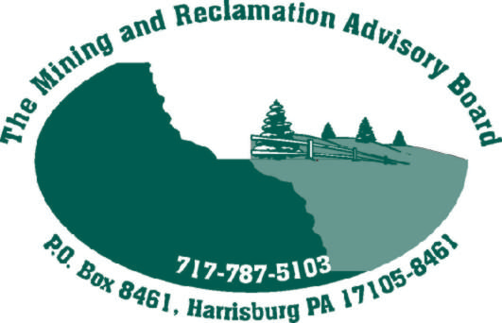

Senator/Representative

RE: Federal Good Samaritan Legislation

Dear Senator/Representative:

The Mining and Reclamation Advisory Board (MRAB) is a statutorily created board charged with providing advice to the Pennsylvania Department of Environmental Protection on issues related to surface coal mining and the reclamation of abandoned coal mines.

There have been several bills introduced into the 109th Congress to address the cleanup of inactive and abandoned hard rock mines. These bills, H.R. 5404 (and its counterpart in the Senate, S. 2780), H.R. 1266, and S. 1848 all offer Good Samaritans protections from liability under various federal laws if people voluntarily clean up abandoned hard rock mines.

The MRAB applauds efforts to protect Good Samaritans who cleanup abandoned mines, be they hard rock or coal. A Good Samaritan bill that provides opportunities to clean up the hundreds of thousands of acres of abandoned mines and polluted mine drainage is necessary because the problem is too big for the government alone. The MRAB supported a Pennsylvania law to provide protections from liability under state law to Good Samaritans who undertake the cleanup of abandoned mine lands in Pennsylvania.

Unfortunately, none of the federal Good Samaritan bills include abandoned coal mines. The MRAB urges you to support federal Good Samaritan legislation and hope that the legislation can also include coal to protect those intrepid Pennsylvanians who are working to make Pennsylvania and America a better place for all.

Sincerely,

MRAB Members/Chairman

